Work, Material, Cost: Resource Types
Without resources doing the work projects would remain a planned schedule. Project 2010 has the ability to offer multiple types of resources to help accomplish the work of a project. The different types of resources are intended to provide flexibility to address most types of resources required during the planning and management of a project.
In this lesson we will discuss the resource types and their intended use:
Work resources
Cost resources
Materials resources
Budget resources
Work Resources
Assigning work resources to a project will allow for resource requirement forcasting and project scheduling based on resource availability. Work resources are usually human resources but can also be facilities, equipment rental and other types of resources. Resource costs can be forecasted using resource assignments to provide projected project budgets. Each work resource entry will contain a resource type, grouping, availability calendar, rate tables and other relevant data.
Effective uses of Work Resources are:
Individual people – actual named resources
Generic resources – these are job titles that can be used as placeholders to identify resources by skill type, skill level or if a resource is unknown. For example: DBA, Developer level 1, Event Planner, Plumber
Group resources – used to state the quantity of a specific type of resource. For example: Helpdesk, Movers, Painters, Attendees, Members
Facilities – a room or area that must be reserved for a period of time
Contracted resources – external contracted labor
Equipment – a machine used for a particular number of hours
Cost Resources
Cost Resources are defined as any thing that will add a dollar(s) cost to a project. Use of Cost resources enables the scheduler to add estimated costs during the planning phase of the project. These costs will be updated into the baseline. When actual costs become available during tracking, the actual costs will be updated and compared against the original estimates to provide a variance.
Cost resources will inherently increase the cost for a task and for the project. Cost resources have no effect on work or duration. The cost value is applied to tasks as a flat amount at the time of assigning the cost expense to a task.
Effective uses of Cost resources are:
Flat estimated cost:
Travel expenses estimated in advance
Flat amount equipment rental
Flat amount facilities rental
Fees: license fees, permits
Estimates for meetings expenses or food provided for events
Estimates for miscellanous project expenses
Estimates for a flat amount for a fixed bid contracted resource when hours are not accumulated
Best Practice: Project 2010 allows for as many cost resources as needed but for simplicity try to consolidate cost resources and keep them to a limited number. The type of reporting required for the project would drive the quantity of cost resources that will be needed.
Material Resources
Material resources are defined as consumables. For example: Reference books for a new product might cost $50 each and 20 books are needed. A material resource would be created with a cost of $50 per book. An assignment would be entered for a task for 20 books. As a result $1,000 is added to the cost of the project. During tracking, the actual number of books would be entered to adjust the quantity if necessary.
The cost of the material resources are added to the total cost of the project and updated into the project baseline. Material resources do not affect work or duration.
Effective uses of Material resources are:
Construction: create a material resource for the cost of 1 foot of trim. Enter the number of feet required for the task
Conference: create a material resource for the cost of giveaway bags. Enter the number of giveaway bags needed for the conference
Servers: create a material resource for the cost of 1 server. Enter the number of servers needed for the project.
Best Practice: If your project will be using a large quantity of materials such as a construction project, using Excel might be less work and a more effective means of keeping track of materials.
Resource Sheet
A work resource is usually a named person or generic skill type.
The resource cost is stored in the resource record on the Resource Sheet.
The number of hours of work will come from the assignment of the resource to the task.
Assignments units will be the quanitity of the resource.
Resources are entered on the Resource Sheet.
To display the Resource Sheet:
Click Task → Gantt Chart view → Resource Sheet
The default table view of the Resource Sheet is called the entry table view which is shown below. This table is a subset of many resource fields of information that are available. This table represents the most important fields that should have values entered for a resource. More information is accessible through the Resource Information dialog box.
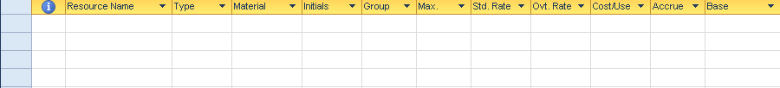
PLACEHOLDER
To enter a resource, type the resource name in the “Resource Name” field. The Resource Name is the key field for the resource data.
Many reports and assignment views will display resources in alphabetical order. A standard of last name first name allows for easy location of resources while making assignments. The database does not allow commas or other special characters. When entering first names it is best to use full first names and avoid using nicknames.
After the name is entered, several fields will be populated with default information. The view below shows the default information that is automatically entered:
PLACEHOLDER
The values for these fields are:
Type: Work is the default and will establish Robert Smith as a work resource. Other values are material and cost and can be changed by clicking the down arrow and changing the type selection.
Material: used for Material resources only – skip for work and cost resources.
Initials: enter full initials for resources. Initials may be substituted on Gantt Charts or reports as needed to shorten reports.
Group: Group is technically a free use field. It is usually used for department, location or skill set. It is one of the few fields populated in the task data when an assignment is created. This information is used to generate reports by groupings of resources. A best practice is that an organization set a standard for the use of this field.
Max units: The value shown above is in the default percentage format but can also be viewed as a decimal value.
To change to a decimal value: Click File → Options → Schedule
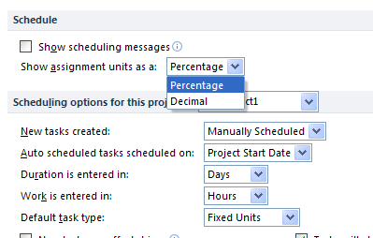
PLACEHOLDER
The Max units’ value is an indicator of the quantity of a resource that is available. Typically an individual should always have a value of 1 or 100%. When entering a group resource such as the number of people on the Helpdesk, enter the number of resources in the group. Each resource represents 1 unit. The available quantity of the resource will be determined by number of hours in a day x Max units. For example if there are 5 people on the Helpdesk, enter 5 or 500% in the Max Units column. With 5 available resources each one can work 8 hours per day. Helpdesk will have 40 available hours of work per day. When Helpdesk resources are assigned to a task, the Helpdesk will be not be overbooked until 40 hours have been assigned.
Some reference sources recommend using a lesser value in the Max units field to limit a resource’s availability. This can produce variable results when creating assignments.
Standard rate: Enter the loaded rate for the resource. A loaded rate is pay scale plus overhead factors. In most organizations, this figure comes from the accounting department with periodic updates. Default is rate per hour but a rate may be enterd as /yr a yearly rate or /w for a weekly rate.
Overtime rate: When using overtime, a rate for the overtime hours may be entered in this field. It will affect only overtime hours entered.
Cost per use: An extra value that may be added to a task over and above the Standard Rate for the resource. For example: A repairman is called to fix a refrigerator. The repairman charges a transportation charge, and hourly rate, plus parts. The cost per use is the transportation charge and would be applied to every task the repairman would be assigned to.
Accrue at: Cost accrual is an indicator of a point in time when costs are incurred. Cost accrual settings have 3 options: incur costs at the start of the task, incur costs at the end of the task, or incur costs throughout the task (prorated). Prorated accrual is the default option.
Base calendar: Each work resource will have a resource calendar associated with it. The resource calendar is based on calendars that have been previously established for the project. The Standard Calendar is the default resource Base Calendar. If the base calendar contains company non-working time it is not necessary to reestablish company holidays, statutory holidays, etc. as all of these will be applied to the resources. Use the dropdown list to select the appropriate calendar for a resource.
The Resource Information dialog box is used to record information about a resource that is not captured in the Resource Sheet.
To view Resource Information dialog box:
Double click the resource you wish to access
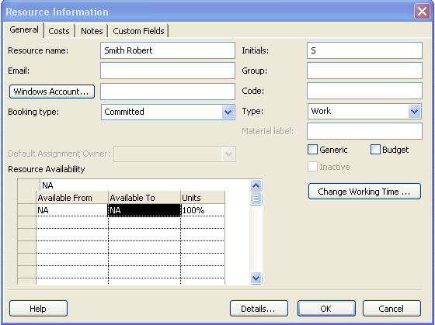
PLACEHOLDER
General tab data:
Email: reference only for Project 2010 standard
Windows Account: Project Server 2010 usage only
Booking type: Project Server 2010 usage only
Code: If you have a code associated with a resource, enter it here. Typically this code is a cost center or department cost category. Free use field for users.
Generic: Click this field to indicate that the resource is a generic resource. A generic resource is a skill type resource to be used as a holding value until a human resource is assigned. When generic resources are used, default base calendar for scheduling.
Budget: budget resources only
Inactive: Project Server 2010 use only
Resource availability: Enter dates if the resource is only available for a particular period of time. For example: An outside contractor is hired for a specific length of time. Enter the date ranges the resource will be available.
To change the resource availability calendar:
From the General tab, click Change Working Time button. The view will appear:
The form looks identical to the form used to change project and base calendars discussed in an earlier module. The view above is the calendar assigned to Smith Robert and it uses the Standard calendar as a base build the calendar for the resource. Changes to this calendar are made in the same way that changes were made to the project calendar.
Click OK to close the calendar form.
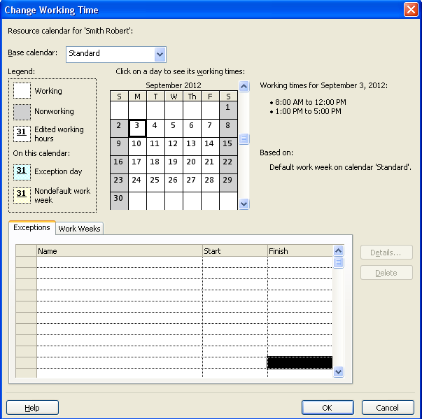
PLACEHOLDER
Cost tab data:
Resource costs are stored on the Cost tab. A resource may have up to 5 cost tables to accommodate varying rates. The tables are labeled A, B, C, D, and E. Labels may not be changed. Some resources will charge different rates when performing different types of work. Each assignment may be assigned a rate table.
If more than one rate table is being used for a resource, enter a note on the Notes tab to help keep track of the purpose of each rate table.
Most organizations using costing experience periodic rate changes. The effective date allows early storage of future rate adjustments and become active based on a cut off date. If a project spans the cut off date, the tasks before the cut off date of the project will be costed at the earlier date rate and the remaining tasks which exceed the cut off date will contain increased rate. It is easy to see that if a project runs late, the cost of the project could increase when using rate tables.
If using resources that come on shore and off shore use the effective date to change rates for resources when they change location.
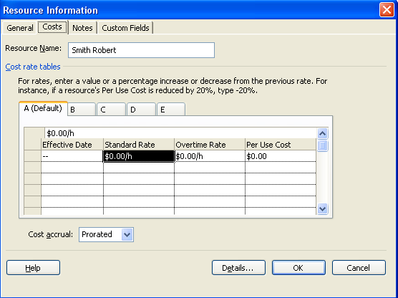
PLACEHOLDER
Notes tab data:
Resource notes are treated the same as task notes within Project 2010. Resource note data has the same formatting and flexibility as task notes.
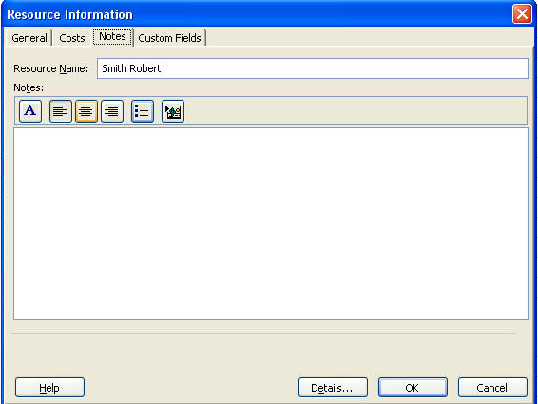
PLACEHOLDER
Custom Fields tab data:
If custom fields have been created for resources, they will be available through the custom fields tab.
Resources may be imported from Active Directory and Outlook to be added to the Resource Sheet. Once they are downloaded from these sources, additional information will be required to complete the entries for the resources.
To access the download function for resources click:
Click Task → Gantt Chart view → Resource Sheet
Click Resource → Add Resources
Add Resource options are shown below.
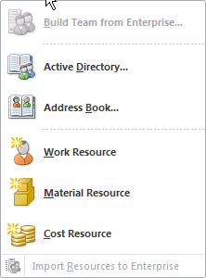
PLACEHOLDER
Calendar

Material Resources
Material resources are supplies to be used by the project, such as paint, building materials, equipment, etc. Material resources are valued based on the quantity of material to be used which is assigned to a task.
Below are the fields associated with Material resources.
Resource name: name of the consumable item
Type: Material
Material label: boxes, gallons, feet, each – the label that describes the material
Standard rate: the per unit/each price
Accrue at: accrual rate for the material
Material resource entries are shown below:
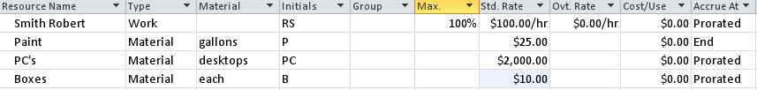
PLACEHOLDER
Cost Resource: Lite
Cost resources are used to apply estimated costs specific tasks in a project. Estimated costs are entered during the planning stage and tracked when actual costs are entered during the execution or control stage of the project.
When naming cost resources include “Cost” as the first word in the name. It will be helpful when assigning cost resources for the name to give an indication of the resource type. Resources appear in alphabetical order when creating assignments and including “Cost” as the first word ensures all Cost resources will be grouped together in the list.
To enter a cost resource:
Resource name: For example: Cost travel, Cost food, Cost room rental, etc.
Type: Cost
No other information is required. Below 3 cost resources have been added. The amount of the cost will be added at the time the assignment is created.
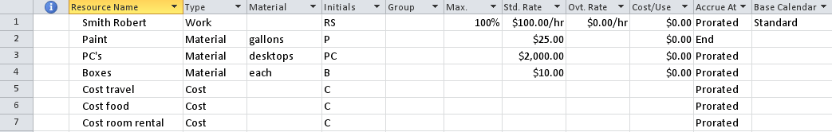
PLACEHOLDER
Assign Cost Resource
The purpose of assigning a cost resource to a task is to add additional estimated costs that the task might incur. Tasks may have multiple cost resources applied but the same resource name may not be applied more than once. Cost resources will not affect the scheduling of a project.
There are several methods available to assign a cost resource to a task. A few are described below:
Create an assignment using the Assign Resources box:
Click Task → Gantt Chart
Click Resource → Assign Resources to display the Assign Resources dialog
Click on the task you would like to assign a Cost Resource to
Click the Cost resource name
Enter the amount of the cost in the cost column
Click Assign
Click Close to close the box
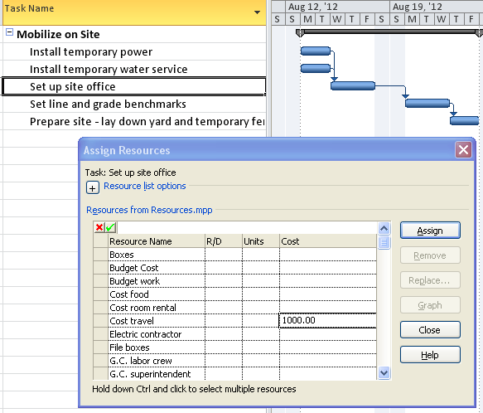
PLACEHOLDER
The result of the assignment will appear like this:
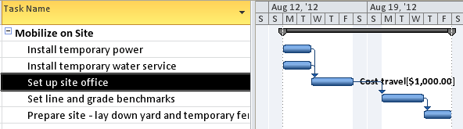
PLACEHOLDER
An alternate method of assigning a Cost Resource to a task is through the Task Information dialog box:
Click Task → Gantt Chart
Double click on the task you would like to assign the cost resource to
Click Resources tab
Click on the next open line and select the cost resource to apply
Enter the cost value in the cost column
Repeat for additional entries
Click OK to close the box
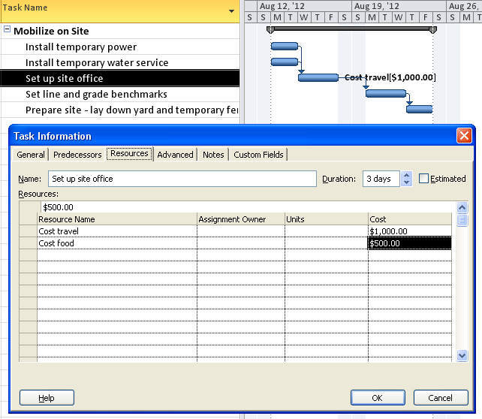
PLACEHOLDER
Project 2010 allows entering a new resource name in the Task Information dialog box or the Assign Resources box. The resource will be added to the Resource Sheet as a new resource using the default field values as a work resource which might not be correct for the resource data needed. Additional field values may also be required to complete the resource data correctly. It is a best practice is to create resources through the Resource Sheet.
Assign Material Resource
Assignment of material resources is very similar to assigning a cost resource to a task. A material resource is assigned by entering the number of items for the material resource assignment.
There are several methods of assigning a material resource to a task. A few are described below:
Create an assignment using the Assign Resources dialog box:
Click Task → Gantt Chart
Click Resource → Assign resources
Click the task you would like to assign a material resource to
Click on the Material resource
Enter the amount of the number of items in the units column
Click Assign
Click Close to close the box
In the example below, 200 Electrical Connectors were assigned to the Install Temporary Power task.
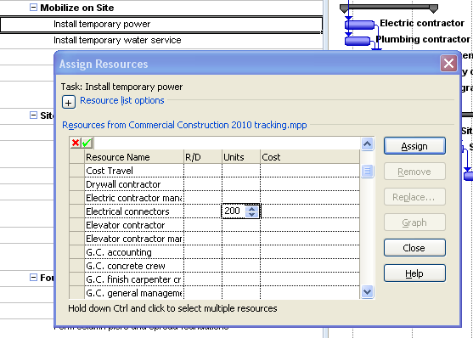
PLACEHOLDER
An alternate way of assigning a material resource can be accomplished using the Task Entry view. The Task Entry view is a preset view that displays the Gantt Chart in the upper portion of the screen and the Task Form in the lower portion. The view is shown below.
To display Task Entry view:
Click Task → Gantt Chart → More Views → Task Entry → Apply
Right click in the bottom pane and select Work
To create the assignment:
Click the task you wish to assign the resource to
Click Resource Name field in the lower pane
Click the down arrow in the Resource Name field to display a list of resources
Select a material resource
Enter number of units or items in the units field
Click OK button on the Task Form to enter the assignment
In the example below “Fencing material” is the material resource. On the Resource Sheet the material was entered as $20 per foot. 400 linear feet of fencing was entered in the units column for the assignment. Below is the result of the assignment.
When creating assignments or making changes in the Task Form as part of a split screen, the second button on the right of the view will say “Previous” As changes are made the value will change to “OK”. The “OK” button must be clicked to have the changes take effect.
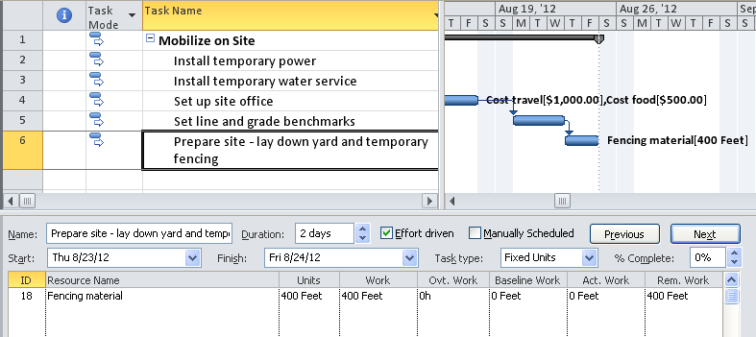
PLACEHOLDER
Right click in the bottom pane and select Cost and view will view the cost of the material.
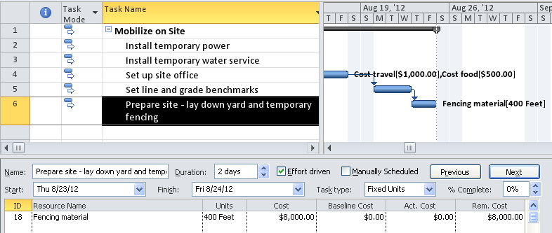
PLACEHOLDER

